The Identification of Disaster Risk Reduction Opportunities
for the DIPECHO Action Plan for the Caribbean 2015- 2016
FOCUS AREAS AND OPPORTUNITIES
Prepared by Alexcia Cooke
UNISDR Regional Liaison Officer

and

Supported by Rico Knight
UNDP Disaster Risk Reduction Intern

October 2014

Table of Contents
1. Introduction | 5
2. Linkages with the Regional CDM Strategy and Framework 7
3. National DRR Priorities 7
3.1. Barbados 7
3.2. Cuba 9
3.3. Dominica 10
3.4. Dominican Republic 12
3.5. Grenada 15
3.6. Guyana 19
3.7. Haiti 21
3.8. Jamaica 22
3.9. Saint Lucia 25
3.10. Saint Vincent and the Grenadines 27
3.11. Suriname 29
3.12. Trinidad and Tobago 29
4. National DRR Priorities Summary 30
5. Regional DRR Priorities 33
6. Conclusion 35

List of Figures and Tables
Figure 1. Key DRR Focus Areas for Barbados (Overall total of 40 references) 9
Figure 2. Key DRR Focus Areas for Dominica (Overall total of 48 references) 11
Figure 3. Key DRR Focus Areas for the Dominican Republic (Overall total of 38 references) 12
Figure 4. Key DRR Focus Areas for Grenada (Overall total of 28 references) 15
Figure 5. Key DRR Focus Areas for Guyana (Overall total of 15 references) 20
Figure 6. Key DRR Focus Areas for Haiti (Overall total of 22 references) 21
Figure 7. Key DRR Focus Areas for Jamaica (Overall total of 83 references) 24
Figure 8. Key DRR Focus Areas for Saint Lucia (Overall total of 74 references) 25
Figure 9. Key DRR Focus Areas for Saint Vincent and the Grenadines (Overall total of 16 references) 27
Figure 10. Key DRR Focus Areas for Trinidad and Tobago (Overall total of 30 references) 29
Figure 11. Regional DRR Focus Areas Based on Priorities Identified at the National Level 34
Figure 12. Countries with DRR priorities corresponding to the focus areas of 2013-2014 DIPECHO Action Plan 38

Table 1. Documents Used in the Identification of National Priorities (section 2) 6
Table 2: National DRR priorities for 2015-2016 ……………………………………………………………………….30
Table 3. 2013-2014 DIPECHO Action Plan hazard focus by Country ………………………………………..37
Table 4. 2013-2014 DIPECHO Action Plan Focus Areas Related to the International Agendas by Country ………………………………………………………………………………………………………………………………39

Acronyms
CD Country Document
CDM Comprehensive Disaster Management
CDEMA Caribbean Disaster Emergency Management Agency
CWP Country Work Programme
CZMU Coastal Zone Management Unit
DEM Department of Emergency Management
DIPECHO ECHO´s Disaster Preparedness Programme
DRM Disaster Risk Management
DRR Disaster Risk Reduction
ECHO European Commission's Humanitarian Aid and Civil Protection Department
EIC Community Intervention Teams
EWS Early Warning Systems
HFA Hyogo Framework for Action
NaDMA National Disaster Management Agency
NEMO National Emergency Management Organisation
NEOC National Emergency Operation Centre
NGO Non-governmental Organisation
SMS Short Message Service
SNGRD National System for Disaster Risk Management (Le Système National de Gestion des Risques et des Désastres)
SIMEX Simulation and drill exercises
UNISDR United Nations Office for Disaster Risk Reduction
VCA Vulnerability and Capacity Assessment

Introduction
The 2013-2014 DIPECHO Action Plan for the Caribbean aims to establish greater collaboration and coordination between partners, allowing programming of common outcomes and the harmonization of practices. Furthermore, it focuses on improving communication and dissemination of DRR key contributions in the region, by capturing evidence of success on how DIPECHO projects have allowed the most at risk communities to anticipate, withstand, adapt and sometimes, recover quickly from disasters.
The DIPECHO Action Plan supports 14 projects with for disaster risk reduction and preparedness activities in a total of 12 countries (Haiti, Dominican Republic, Cuba, Jamaica, Saint Vincent & Grenadines, Dominica, Grenada, Saint Lucia, Suriname, Guyana, Barbados and Trinidad and Tobago). A total amount of total of €8.5 million has been allocated for interventions in the Caribbean for this time frame.
Within the framework of the 2013-2014 DIPECHO Action Plan for the Caribbean, the United Nations Office for Disaster Risk Reduction (UNISDR) through its Regional Office in the Americas is responsible for the implementation of the project “Strengthened Disaster Risk Reduction in the Caribbean through greater fostering of the Hyogo Framework for Action priorities for action at the local, national and regional levels”. The UNISDR regional project includes the following elements:
- Improving communication and dissemination of DIPECHO DRR tools and initiatives in the region,
- Further advancing in the development of a common strategy towards DRR, as well as
- Contributions to the consultation process leading to the post-2015 framework for DRR.
One of the activities related to the second point is the identification of national and regional DRR priorities that will inform the 2015-2016 DIPECHO Action Plan.

The analysis undertaken to identify the national and regional DRR priorities is based on the review of 11 Disaster Risk Reduction Country Documents, also referred to as DRR country profiles, and the identification of DRR priorities at national or sub-national level during the process of preparing or updating of the country documents.

The Comprehensive Disaster Mangement (CDM) Country Work Programmes (CWPs) for the countries were also used to 1) highlight the commonalities between DRR priorities identified during the CD and Criteria process and the CWPs and 2) to further identify DRR priorities that were not identified during the CD and Criteria application process.

The DRR country documents provide an overview of DRR situation in a country, it refers to DRR accomplishments and gaps as well as to recommendations on strategic and future prospectives. The key recommendations in relation to DRR are supplemented by the results of the application of the tool called “Criteria for Identifying Key Actions for Disaster Risk Reduction (DRR) Planning in Latin America and the Caribbean” also referred to as the Criteria. The Criteria tool is being applied in 10 out of the 12 countries reflected in this report out of which 7 countries identified priorities at the national and three at the sub-national level. The documents used are indicated in Table 1.

Table 1. Documents Used in the Identification of National Priorities (section 2)
Country | Country Document Version | Criteria Application Level | Timeframe of CDM Country Work Programme
Barbados | Draft 2014 | National | 2012-2015
Cuba | Not available | Sub-national | NA
Dominica | Final 2014 | Sub-national/National | 2012-2016
Dominincan Republic | Final 2014 | Sub-national/National | NA
Grenada | Draft 2014 | National | 2015-2019
Guyana | Draft 2014 | National | 2012-2015
Jamaica | Draft 2012 | National | 2011-2014
Saint Lucia | Draft 2012 | National | 2013-2017
St. Vincent and the Grenadines | Draft 2014 | National | 2014-2024
Suriname |  | Sub-national
Trinidad and Tobago | Draft 2014 | National | 2010-2015
* Haiti did not developing a DRR country document. In order to identify the DRR priorities, a consultation meeting was organized.
** The country documents are available online: http://unisdr.sigimo.com/contenido/85-documentos-pais.html

The information presented in this document is therefore a synopsis of the priorities presented through the gaps identified in the country documents and the high and medium-level priorities identified by the countries through the application of the Criteria. The priorities were assessed for each country and a description of the country situation provided. The analysis of the CDs, Criteria results and the CWPs was also matched against geographical priorities and priorities related to international agendas identified for the 2013-2014 DIPECHO Action Plan. These results are provided in Annex 1.

The results are illustrated in the country chapters in text form and bar charts to highlight which DRR priorities were given the greatest emphasis in the documentation available.

In a second phase, countries revised the DRR priorities identified through the analysis of the country documents and added key elements during the Caribbean DIPECHO workshop 2014 which took place from 16 to 17 October 2014 in Montego Bay, Jamaica. The summary of the priorities presented during the workshop can be consulted in Section 4.

Within the framework of the 2011-2012 DIPECHO Action Plan for the Caribbean a consultation process was undertaken in order to identify focus areas for the 2013-2014 DPECHO Action Plan. The focus areas identified through this process remain largely relevant for countries and the Caribbean Region. The focus areas include: local disaster management, hazard mapping analyses and assessments, early warning systems, institutional linkages and advocacy, information education and communication, small scale infrastructure projects and services, baseline data development, vulnerable groups, institutional capacity strengthening, map making and computerisation of data, research and dissemination and stock building of emergency relief items.

Linkages with the Regional CDM Strategy and Framework
This document also captures the linkages between the DRR priorities identified in the CD and Criteria process and the key actions outlined in the Comprehensive Disaster Management (CDM) Country Work Programmes (CWPs). The CWPs define actions aligned with the Regional CDM Strategy and Results Framework (2014-2024). The new CDM strategy and framework emphasises the nexus of Climate Change and Disaster Risk Reduction in building resilience in the Caribbean and promotes an integrated approach to risk management. In particular, the CDs and the Criteria contribute to the identification of actions related to mitigation and preparedness within the CDM Strategy.

Reference has been made in the footnotes to the actions and outcomes being undertaken or planned at the national level that correspond to the DRR priorities. There are also cases where the actions in the CWPs are not directly linked to the priorities identified in the CD and Criteria process. These CWP actions are further highlighted in the narrative on the country.

National DRR Priorities

Barbados
The priorities identified for Barbados based on the draft CD and Criteria outputs and the CWP for 2012-2015 are reflected in Figure 1.

The area of legal and institutional capacity strengthening for DRR was a major area based on the frequent reference to Acts that do not have the accompanying regulations and key legal and institutional instruments that are still in draft.

The areas highlighted for attention included:
- Improved legal and institutional framework for DRR
- High quality risk and vulnerability analyses
- Transition to proactive approach to DRR
- Improved financial risk management
- Improved public education and awareness of disaster risk
- Capacity strengthening to promote the integration of DRM into sectors,

It was also reported in Barbados’ draft country document for DRR that a lack of high quality information on disaster risk on the island has been a major constraint to the implementation of Comprehensive Disaster Management. Specifically, the document highlighted the lack of baseline data modelling tools, the need for linkages between coastal vulnerability and a national risk information database with GIS and modelling capabilities, the need for comprehensive vulnerability and risk assessment of the coastal zone which utilizes climate modelling and long term modelling and evaluation tools for decision making in coastal zone management.

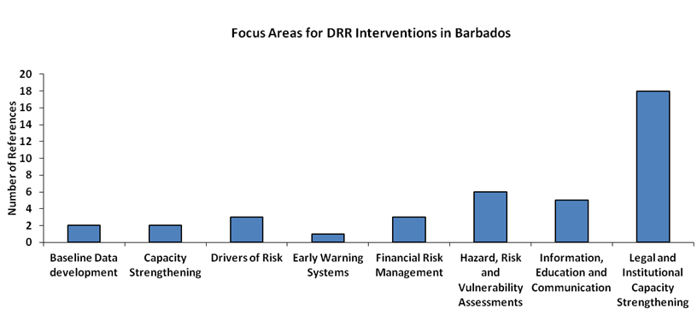
Figure 1. Key DRR Focus Areas for Barbados (Overall total of 40 references)
The need for a change from reactive DRM to proactive DRM was continually stressed in the country document. As such, the need for greater awareness to cost-effective preventive approaches was emphasized. These approaches may encompass, and depend on other potential priority areas e.g. improved legislation for DRR e.g. building codes and setbacks as well as increased awareness and education initiatives for DRR and improved financial risk management. Public education of, and awareness on disaster risk were deemed inadequate in the country document. Also, the improvement of financial risk management was highlighted as an area vital to proactive DRM.

Finally, integrated disaster risk management, and capacity building for such, was highlighted as a strategic area for DRR in Barbados. This may be an area of high concern as it is believed that a national approach to natural hazard management and disasters, which embraces integrated DRM thereby increasing capacity, is a prerequisite to solve some of the aforementioned challenges (lack of high quality disaster risk information, lack of appropriate legislation, inadequate public education and awareness of DRR and need for a proactive approach to DRR).

The draft version of the country document proposed that this integrated approach to DRR could be facilitated through the implementation of a national integrated DRM strategy and institutional strengthening at national and sectoral levels. Specifically, the strategy would involve a multi institutional or multi-sectoral approach to DRM and outline specific roles for the CZMU, DEM and planning, environment, and public and private sector agencies.

Cuba
Cuba is currently finalizing its DRR country document. Information was shared related to the application of the Criteria tool at sub-national level. The following DRR priorities have been identified:
- Reducing earthquake risk for the three south-eastern provinces
- Strengthen the hydro-meteorological EWS in the watershed of Zaza and Ciénaga de Zapata
- Prioritizing flood protection in the watershed of Zaza in Santi Spiritust (in the center of the island) with the involvement of the National Institut for Hydrological Resources and local governments
- Combining DRR and CCA measures towards flood protection and mitigation to in the Cienaga de Zapata watershed which is the largest wetland in the Caribbean.

The final version of the DRR country document will need to be reviewed in order to capture all priority areas.

Dominica
In Dominica, the documentation highlighted a heavy focus on improving the legal and institutional framework for DRR and the drivers of risk (Figure 2). There is also a need for hazard, risk and vulnerability mapping and monitoring as well as capacity strengthening. There is a strong community level arrangement that requires strengthening to support the national system.

Specifically, the documentation highlights the need for:
- Capacity strengthening and interagency collaboration
- Improvement of DRR related legislation
- Integrating climate change and forecasting into DRR strategies
- Hazard mapping and monitoring
- Early Warning Systems
- Social drivers of risk
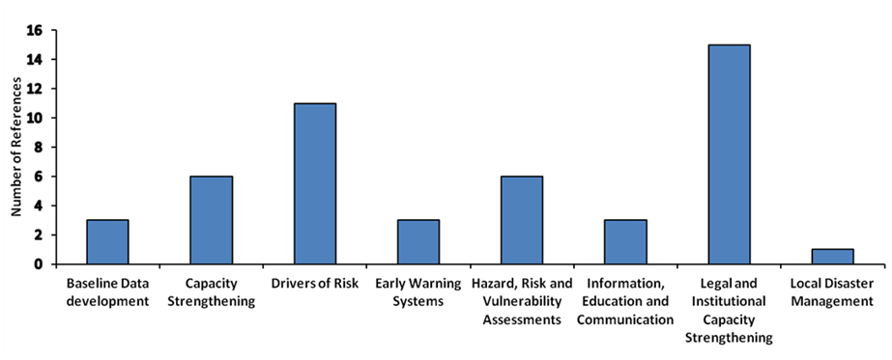
Figure 2. Key DRR Focus Areas for Dominica (Overall total of 48 references)
As outlined in the Dominica country profile on DRR, human capacity constraints exist within agencies involved in disaster management on the island. Capacity challenges for emergency and disaster response are also encountered within some communities and sectors. The improvement of capacity for vulnerability and risk assessment and monitoring as well as enhancing coordination and implementing capacity of agencies were highlighted as recommendations for improving resilience to hazards. Specifically, clarity of responsibility among agencies involved in DRR was recommended this could ensure that duplication is avoided.

Legislation and regulation facilitating DRR was continually highlighted as an area of concern throughout the Dominica country profile on DRR. Three key weaknesses in DRR in Dominica related to legislation were identified:
- lack of comprehensive legislative framework,
- weak and outdated legislation and
- lack of enforcement of legislation and regulations.

As a result, updating of existing legislation was seen as a high priority action as it was a main driver of risk. Specific concerns include the inadequacy of legal and policy frameworks which allocate responsibilities for DRR agencies and lack of enforcement of existing legislation e.g. building codes.

Another concern of high priority is the absence of climate change impacts in risk management strategies. It was specifically noted that very few records on risk scenarios and impacts of climate change exist. Also, of note was the lack of detailed studies of probability forecasting and forecasting in general, mainly existing for meteorological hazards. In relation to this, it was noted that severe data gaps exist within historical records of hazards, exposure and disasters.

There was also mentioning of limited analytical capacities and as such specific concerns which were mentioned include: the lack of hazard maps which demonstrate areas of vulnerability, lack of a composite map for multi-hazard scenarios, the absence of a completed repository of data on impacts; and the lack of monitoring for hazards other than hydro-meteorological and volcanic hazards. Another major concern which was mentioned in the country document was the lack of EWS and monitoring systems for most areas of high exposure or recurring impact and the subsequent gaps in coverage and information.

Specific socio-economic factors in Dominica, and their natures of being drivers of risk, were highlighted as areas of concern. Notably, human induced degradation and its relation to increased exposure and vulnerability to hazards was identified as an area of high priority in DRR. Specific areas of weakness include poor socio-agricultural practices (deforestation and soil erosion), housing settlements on slopes and land slippage, poorly designed storm drains and overcrowding. Finally, it was noted that funds for preparedness and management of response are limited and that there is a need for financial incentives for such at the community level.

Apart from the CD preparation and identification of DRR priorities through the Criteria application, the CWP has highlighted specific outputs that can contribute to DRR. These specific outputs are:
- Multi-hazard public education and awareness strategy developed and implemented (Output 4.3)
- Development and testing of Disaster Management Plans for schools and other critical infrastructure in populous communities (Output 3.1c)
- Comprehensive Disaster Management Programme for incorporation into school programme developed and executed (Output 4.2b)
- Sensitization programmes developed for homeowners and the building and construction sector on building codes and safer building techniques (Output 4.2c)

Dominican Republic
The information presented for the Dominican Republic is based on the revision of the country document and the identification of DRR priorities at the national level as well as in 6 hydrological regions based on the regionalization of the Ministry of Environment.

The priorities most reflected refer to:
- Need for legal and institutional strengthening
- Capacity strengthening at local level
- Need for hazard, risk and vulnerability assessment
- Improved early warning systems and information
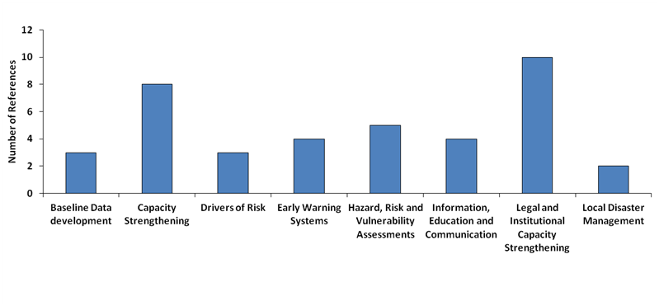
- Enhanced education and communication on DRR
Figure 3. Key DRR Focus Areas for the Dominican Republic (Overall total of 38 references)
Dominican Republic is prone to recurrent hurricanes, storms, floods, fires and droughts, being among the top ten countries with a higher climate risk index. Economic growth, industrial development, high population density and pressure on environment are present in the main cities. It is therefore mandatory to adopt a multi-hazard approach that encompasses technological hazards in urban areas.

Higher coordination and operationalization among the central and local actors is needed, as well as strengthening a proactive approach to risk in the various sectors and local institutions. The new Disaster Management Law is an opportunity for decentralization of responsibilities, local budgetary allocation, harmonisation of the legal and normative framework and the inclusion of DRR into planning.

Sectoral and technical institutions have been establishing Risk Management Units and elaborating DRR Plans. At the local level, Prevention, Mitigation and Response Committees and Municipal Units for Risk Management have been established. Additionally, Development Boards and Municipal Development Plans are an alternative for the inclusion of DRR in local planning. The Community Prevention, Mitigation and Response Networks have proven to be an efficient manner to tackle emergencies, as demonstrated during the hurricane Isaac impact in Barahona province (August 2012). However, challenges in integrating DRR within land use planning, environmental sustainability and CCA still remain.

Significant progress has been made in terms of knowledge generation comprising seismic hazards, climate change adaptation and capacity building. This information has to be disaggregated at the sub-national level, and the authorities have to be trained and sensitized. Gender mainstreaming and inclusion of vulnerable groups in the policies, plans and projects remain a challenge, despite in the last two years specific initiatives have been undertaken, namely in the South Region and in areas with high poverty prevalence.

The 2014 country document consultation process identified priorities at both the sub-national and national level. The priorities are supporting the 5 programmatic focus areas of the National Plan for Disaster Risk Management. The following elements provide a selection of priorities identified for each focus area of the National Plan:

  - Promote knowledge development, and risk analysis and dissemination.
- Consolidation of the National Integrated Information System
- Create and update the various databases on historical events at the national and sub-national level, and promote dissemination.
- Integrate climate change adaptation into risk management studies at the sub-national level.
- Disseminate plans, tools and sectoral studies on risk management to be incorporated into municipal and provincial level.
- Harmonization of concepts, methodologies and tools for planning
- Conduct seismic micro-zoning and elaborate risk maps.

  - Strengthen reduction and monitoring of underlying factors.
- Incorporate DRM in development strategies and plans at the municipal and provincial level.
- Elaborate land use and urban use plan at the sub-national level.
- Elaborate DRM plans at the municipal and provincial level.
- Promote safety assessments in public and private hospitals as well as in schools.
- Elaborate Integrated Waster Resources management plans, with focus in extraction of aggregates from river basins, reforestation, and soil protection.

  - Enhance mechanisms and practices for early warning and response
- Elaborate emergency and contingency plans at the municipal and provincial level and disseminate those already existing.
- Design and implement Tsunami EWS.
- Implement and expand coverage of hydro-meteorological EWS.
- Strengthen monitoring and forecast capacities in hydro-meteorological hazards

  - Training and education
- Capacity building for national and local stakeholders.
- Sensitize authorities and technicians of local governments, relief institutions, civil society and community networks about Law 147-02 and regulations.
- Train the construction sector in hurricane and seismic resistant standards.
- Advocate for regulation and provide guidance to the media in DRR issues.

  - Building of inter-institutional capacities for DRM
- Integrate DRM planning in the decision-making process of Provincial and Municipal Development Committees.
- Support decentralization and autonomy in decision-making of local governments, with regards to emergencies and disasters within their territory.
- Promote allocation and decentralization of financial resources to local governments for DRR.
- Implement, train and equip Municipal and Institutional Units for DRM.
- Strengthen inclusion and coordination of vulnerable communities (networks) with the Coordinating institutions for prevention, Mitigation and Response.

The 2014 country document for the Dominican Republic provides all details related to the sub-national priorities which are not specified in this document.

Grenada
Grenada’s DRR backdrop is similar to that of many of the other Caribbean countries. The legal and institutional framework was identified as a key area for DRR intervention (Figure 4). The need for hazard, risk and vulnerability assessments was also identified among others.
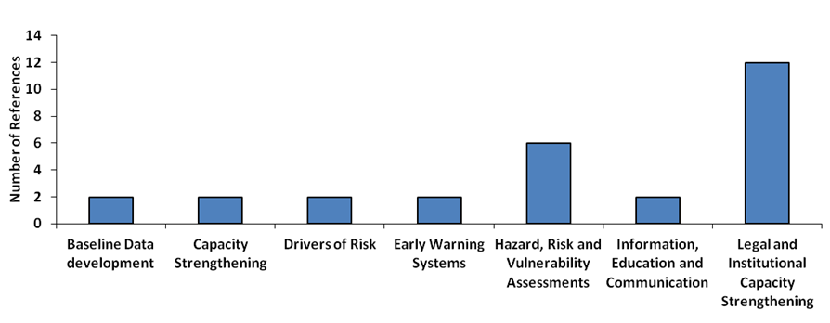
Figure 4. Key DRR Focus Areas for Grenada (Overall total of 28 references)
The country document specifically highlighted the need for
- Improvement of DRR Legislation and institutional arrangements
- Human and Financial Resources for DRR
- Need for hazard data and monitoring
- Capacity building
- Increasing education and awareness about DRR

During the national consultation workshop, the following four priorities were identified based on the application of the criteria. Annex 4 provides further details.
- Hazard Maps based on probabilistic criteria
- Enhancing the capacity of institutional response structures
- Budgetary allocation for resources for preparedness and emergency response
- Development of a legal and regulatory framework for DRM and Environmental Management
- Volunteer support coordination
- Development and maintenance of geo-referenced and territorially disaggregated records of frequent impacts of hazards related to seasonal events (droughts, floods or landslides)
- Implementation and development of studies and action plans on multi-hazard or trans-border hazard conditions, including extreme climate variability events such as the impacts of climate change
- Development of strategies for reducing vulnerabilities for the poor populations
- Improve access to the sectors of the population with limited access to essential services and reduce the vulnerability of essential services
- Development of a regulatory framework for DRM or for environmental management
- Implement planning processes or control over the implementation of the urban and rural land use planning regulations. Need physical control mechanisms for the occupation, use and transformation of urban landscape
- Development of formal coordination mechanisms by State agencies for Risk Management and Environmental Management

It was asserted in the Grenada Country Profile for DRR that legislation which facilitates DRR in Grenada is outdated and fragmented. Mentioned shortcomings include:
- gaps in legislation for declaring a disaster
- lack of legislation which allows the NADMA to undertake its responsibilities
- lack of alignment of the National Disaster Management Plan with legislation
- legislation that mandates the preparation of hazard maps
- lack of legislation for Contingency Plans and their testing
- lack of legislation for acquisition of insurance

Policy which facilitates DRR was also highlighted as a concern. Concerns included the lack of a national disaster policy including policy, standards and regulations for the preparation, publication and revision of hazard maps as well as the lack of a formal disaster recovery policy. There was also mention of the absence of a policy at the sectoral level to encourage incorporation of risk management and resilience building into the on-going operation operations of the sectors. Also of note was the lack of any plan to identify and reduce risks associated with structures not meeting the building code.

A number of resource constraints, mostly pertaining to financial, technological and human resources were highlighted in the draft country document on DRR. Access to resources for DRR was deemed limited for the NaDMA Secretariat, Sub Committees and District Committees as well as NGOs and the general public of Grenada. Such constraints include limited financial resources and inadequate human resources assigned to relevant ministries and the resulting implications for the:
- Integration of DRR into national environmental policies;
- Implementation of social development policies and plans to reduce vulnerability of populations at risk;
- Implementation of economic sectoral policies and plans to reduce vulnerability of economic activities;
- Incorporation of DRR elements into planning and management of human settlement (e.g. building codes).

Specific financial resource constraints identified included the lack of incentive schemes to encourage risk transfer, lack of insurance for public assets, lack of financial market instruments for DRR, no capital or recurrent budget allocated for rehabilitation and reconstruction after a disaster and high costs of detailed risk assessments.

Issues related to the existence and acquisition of hazard data, risk and vulnerability studies were also outlined in the Grenada country document. It was mentioned that a formal assessment of hazards and related risks has not been done for Grenada, although a number of VCAs have been conducted by the Red Cross. There is also the lack of:
- a formal recording and storage of disaster incidence and impacts;
- hazard specific risk assessments of persons, social, economic infrastructure and bio-geographical assets;
- work identifying and evaluating disaster risks at community level, development of what-if scenarios and mitigation plans (except for a few communities).

Also of special note was the finding that risk perception, though generally high within the island, was not based on scientific evidence. Finally, one notable challenge related to human resources was the low expertise in detailed risk assessment methodologies among national professionals.

Limited capacity for DRR, specifically in relation to responding to hazards, implementation of DRR policy and incorporating DRR in plans, was deemed a DRR related concern. Specifically, it was mentioned that the NaDMA and District Committees are limited in their ability to respond to challenges concerning hazard risk, due to their lack of control over the necessary budgetary and technical resources. Also, the Physical Planning Unit (PPU) was noted to be constrained in its ability to implement building code legislation due to the lack of capacity to do so (missing necessary skill set among staff). In relation to hazard response, it was stated that the NaDMA does not have an Emergency Response Committee and lacks response plans for prevalent hazards. Emergency response is instead managed through sub committees and district response plans. However, these plans lack provisions for the evacuation of the vulnerable population (children, elderly, and persons with mobility challenges). Finally, response capacity and capacity to include DRR in plans, for NaDMA, Private Sector, NGOs and the public, was deemed low or medium.

Few challenges which could be related to insufficient public education and awareness were identified. Lack of awareness of impact zones by community members was highlighted, as well as limited information on a community level relating to community specific hazards. For community residents, knowledge about hazards is limited to historical experience and anecdotal information. Lack of trust of insurance companies and low level of understanding how insurance work was mentioned as well, and this may be seen as a shortcoming in existing education initiatives for DRR education.

In addition to the linkages made with the CWP, there were additional actions (Box 1) that the country has targeted for implementation. The actions include:
Box 1. Additional DRR Priorities in the Country Work Programme
Outcome 2
2.1.1. Expand NaDMA’s range of radio coverage to cover Grenada, Carriacou and Petite Martinique
2.1.2. Employ usage of broadcast interrupt system for information dissemination
2.1.3. Encourage telecommunications companies to disseminate information via SMS
2.1.4. Train personnel in Emergency Communication
2.2.1. Early warning systems for volcano hazard (water and land), tsunami, and storm surge implemented in Grenada, Carriacou, Petite Martinique
2.2.2. Measures to safe guard the EWS are put in place
2.2.3. Utilization of climate forecasts produced by CARICOF (Caribbean Climate Outlook Forum) in order to predict the likelihood of storm surge - induced events
2.2.4. Procure hydrometer to monitor river water levels and to identify a hydrological drought. This device will allow information to be shared in real time.
Outcome 3
3.7.1. Review and update the key personnel register
3.7.2. Establish and maintain an online register of all equipment and supplies
3.7.3. Regular review of all registers

Guyana
The overall national development strategy in Guyana is based on environmental protection with focus disaster mitigation (mainly through structural measures), low carbon economic development, climate change adaptation, and lessening of socio-economic vulnerability. This provides an enabling framework for DRM. Regarding specific DRM measures, a new legal framework has been drafted, with a comprehensive disaster risk management approach.

When the new legal framework is enacted, it will provide the basis for major changes mainly affecting:
- Institutional framework with authorities to enforce incorporation of DRM. The Civil Defence Commission obligated to support the various institutions. Review of National DRM Platform role, composition and functions to make it more functional.
- Need of inclusion of DRM into various sectors (agriculture, health, education, urban and land planning, etc.). Progress has already started.
- More coordinated hazard, vulnerability and risk assessments.
- Legal framework for EWS, but needs to be operationalised.
- Implementation of a DRM Fund, not only intended for response and recovery.

Figure 5 highlights the key areas of work that were identified among the priorities for Guyana.
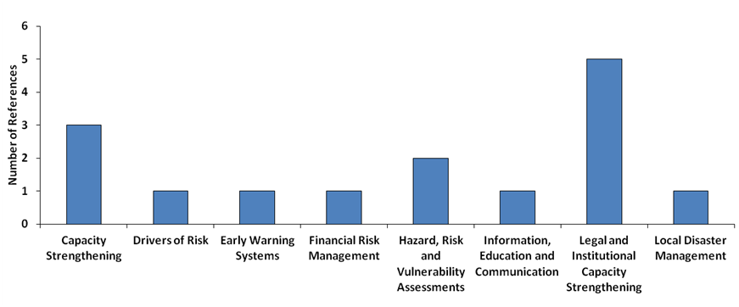
Figure 5. Key DRR Focus Areas for Guyana (Overall total of 15 references)
Specifically, the gaps and constrains that attract more attention and/or priorities in the country include the following:
- Improve capacities at the CDC for moving from a responsive to a comprehensive approach.
- Improve capacities at the different institutions to incorporate DRM considerations into planning, at the national and sub-national level.
- Hazard, vulnerability and risk assessments need harmonization. Significant progress at the national level, but needs strengthening at the sub-national level.
- Limited capacities for Early Warning. Strong progress in floods, but other hazards need to be considered, namely droughts and fires.
- Shelters need to be constructed / upgraded.
- Response capacities at the sub-national level need to be operationalised and strengthened. Drills and table-top exercises need to be conducted regularly.
- Limited risk transfer mechanisms. Infrastructure, buildings and crops. National, sub-national and household level.
- Limited funding for replication of Community Based Disaster Risk Management initiatives.
- Limited Land Use Planning. A national plan has been developed, but sub-national plans need to be operationalised.
- Urban planning and building codes need to further incorporate DRM considerations. Enforcement capacities in this regard need to be strengthened.
- Considerations to the most vulnerable groups and inclusion of gender issues need to be mainstreamed in all institutions.
- Significant progress in DRM public education and awareness campaigns, but funding is needed for better outreach the various regions.
- Curricula include DRM considerations, but a more comprehensive approach is needed, further integrating DRM, environmental studies and climate change.
- Limited planning for early recovery.
- Limited collaboration with neighbouring countries in tackling trans-boundary risks.

Haiti
The DRR priorities for Haiti were identified during the consultation meeting reviewing the national disaster preparedness priorities related to the 5 HFA priorities. Specifically the sources of information included extracts from the Department for Civil Protection (DPC) Action Plan and recommendations to the ECHO from the National System for Disaster Risk Management (SNGDR) in order to ensure that contribution support the national priorities.

The priority areas correspond mostly to the areas of legal and institutional capacity and strengthening, information, education and communication and capacity strengthening (Figure 6). The priority areas captured the Criteria include:
- Legal and institutional capacity strengthening
- Enhanced information, education and communication
- Capacity strengthening
- Baseline data development
- Strengthening of early warning systems
- Small scale infrastructure projects and services
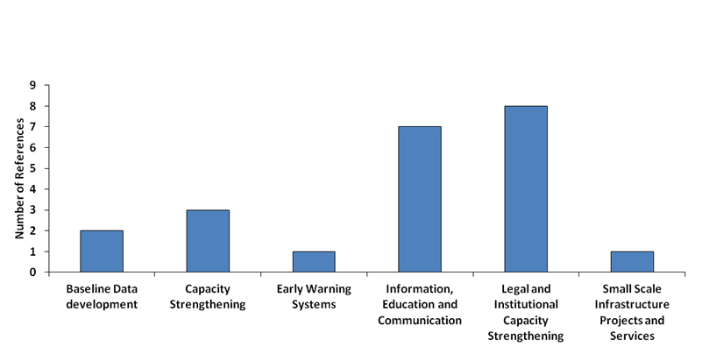
Figure 6. Key DRR Focus Areas for Haiti (Overall total of 22 references)
A key priority for Haiti as it relates to their legal and institutional framework is the development of a national strategy for risk reduction. Such a strategy would provide the basis for the integration of DRR into different sectors and would serve to improve coordination with DRM actors through the roles and responsibilities established. It was further mentioned that the development of a country document for DRR for Haiti could serve as reference and guide external contributions and assist in planning and decision making processes.

It was emphasised that the inter-agency and inter-sectorial coordination related to DRM should continue supported by a DRR related communication strategy.

Other priority areas identified for Haiti include the capacity strengthening of the national system for the collection, processing and analysing information at all levels, baseline data and information, early warning systems (strengthening and extending existing alert systems) and mitigation works.

As it relates to the area of knowledge, information, education, the focus identified is for strengthen the public information system on DRR by developing mechanisms to access as well as archiving and sharing information on DRR as well as setting up a special campaign focusing school safety.

Strengthening of the response capabilities was highlighted for attention through technical preparation, monitoring of response actions to disaster victims and the management of the influx of victims as well as the standard operating procedures for the Community Intervention Teams (EIC).

In terms of specific projects reference was made to the need to focus on urban risk, tsunami risk projects as well as replication and scaling up of existing projects and initiatives including lessons learned from 2010. The following projects/initiatives were mentioned strengthening SIMEX (simulation and drill exercises) at central and local level, “Fridays of Civil Protection”, “Urban Observation”, dissemination of the “Emergency Family Plan”, development and implementation of a Tsunami Risk Reduction project in Grand Sur based on the achievements of the UNESCO coordinated project in Grand Nord.

Jamaica
The analysis of the priorities for Jamaica was undertaken based on the 2012 version of the CD as well as Jamaica’s Logical Model and Performance Monitoring Framework (PMF). The CD highlighted the progress that Jamaica has made in DRM but has also noted that if gains are to be made, there needs to be an enabling framework that includes the sectors and agencies and an improved local disaster management system. Based on the analysis (Figure 7), the focus areas for Jamaica are:
- Legal and institutional capacity strengthening
- Research and understanding of drivers of risk
- Need for hazard, risk and vulnerability assessments
- Capacity strengthening

As it relates to the legal and institutional capacity strengthening, the legal framework for DRM was highlighted given outdated laws and legal provisions and the draft status of some laws. Further, the need for the full integrations of DRR into key sectors and agencies was highlighted along with the necessary budgetary allocations for reducing the vulnerability of populations most at risk. Institutional strengthening also relates to the lack of local government systems to support and sustain the existing efforts at the national level.

The social and environmental drivers of risk are recognised in Jamaica. The vulnerable populations have been identified. There is however no systematic coordinated effort to research and understand the drivers of vulnerability. In addition, the many disaster plans do not include procedures for vulnerable populations. In terms of the required inputs for policy making, sex disaggregated data on vulnerability needs to be collected and integrated. In short, DRR laws and policies need to capture vulnerabilities and allow for interventions that meet the particular needs.

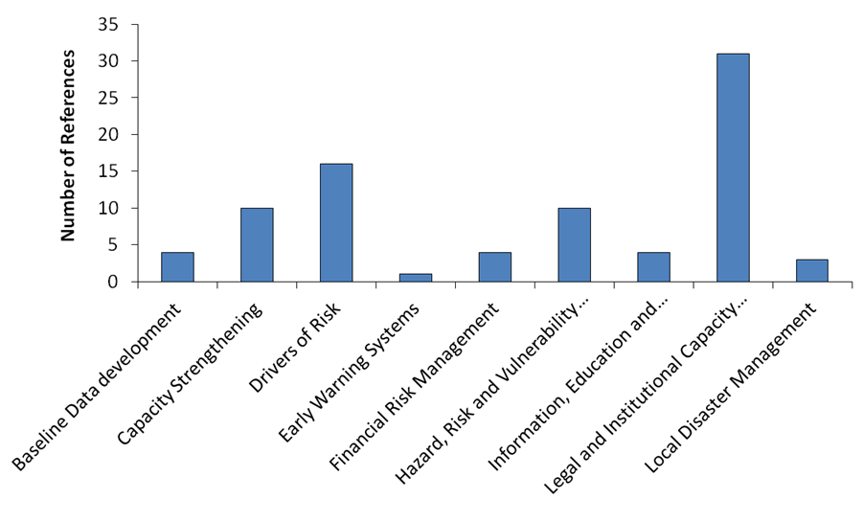
Figure 7. Key DRR Focus Areas for Jamaica (Overall total of 83 references)
The need for hazard, risk and vulnerability assessments was also identified within the CD. The focus has been placed on the need for hazard data collection and mapping for all hazards noting the absence of a comprehensive multi-hazard risk analysis for Jamaica. It was noted that many parishes do not have hazard maps, vulnerability assessments or risk analyses to guide decision making. In addition, risk scenario development that includes detailed building inventories, specific damage data for building types and the value of buildings, the value of natural resources, agriculture resources and government assets and standardized methods for assessments is required. Methods for climate-related hazard assessment such as flooding and storm surge are required and must factor climate variability and climate change in the analyses.

As it relates to capacity strengthening, Jamaica’s DRR capacity is weak at the national, community and local levels. Specifically, capacity for technical review at parish level is limited and Local Authorities lack the adequate capacity to administer its Disaster Management Responsibility. It has been noted that there is a general lack of resources to address capacity building in all vulnerable communities that exists. The lack of resources be it human, financial, technical or operational and lack of institutional commitment remains Jamaica’s greatest challenge. Capacity development in DRR is also required in all sectors, except tourism and agriculture.

The other focus areas are related to the development of baseline data, early warning systems, information, education and communication and local disaster management.

Saint Lucia
The country document for Saint Lucia (prepared in 2012) and the Criteria applied under the 2013-2014 DIPECHO Action Plan were used to identify DRR priorities. The documents highlight the need for legal and institutional strengthening, information, education and communication, hazard, risk and vulnerability assessments as key areas for attention (Figure 8). Capacity strengthening, baseline data development and local disaster management were among the most highlighted priorities for intervention.
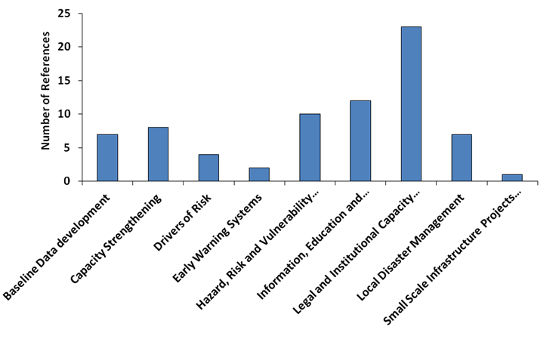
Figure 8. Key DRR Focus Areas for Saint Lucia (Overall total of 74 references)
As it relates to the legal and institutional frameworks, the following priorities were presented:
- Overall governance structures need to be improved to ensure the inputs from the local to national level as well as the necessary coordination among DRR partners.
- There is a need for the development of institutional and community capacity (systemic, institutional and individual), including expanding the information and knowledge base, in terms of up-to-date scientific information, and local knowledge and expertise that remain key requirements for DRR.
- The DRR approach requires strengthening of the national multi-sectoral platform. This platform would drive a DRR policy, planning and implementation framework that is transparent, fully participatory and accountable. This will require fully developed, coordinated and coherent action on DRR across different sectors, public and private sector, and between central and local governments.
- Adequate resources allocations in the budgets for the efficient and effective functioning of the DRR mechanisms.
- Regulate urban and local development with DRR instruments and mechanisms such as building codes and land use planning

The area of information, education and communication corresponds to the section of the CD that deals with knowledge management. The consultant highlighted the need for education and awareness and research and knowledge management as ways to enhance resilience at various levels of society. Participants at the national validation workshop proposed that public awareness and education campaigns. Specific actions are suggested for addressing the drivers of risk by targeting the schools, community groups, farmers and seeking out champions for the DRR cause at the Cabinet level.

As it relates to hazard, risk and vulnerability assessments, there are still no structured systems in place to formally monitor, archive and disseminate data on key hazards and vulnerabilities. There is also the absence of a comprehensive national multi hazard database or archive with protocols for information sharing which impedes the use of mechanisms to inform the local and regional DRR efforts. Infrastructure for the systematic research, recording and analysis of the hazards which have impacted Saint Lucia and the impacts of these hazards also need to be established. There is a need to improve information on how hazards are changing with detailed risk assessments from diverse sources of knowledge.

Capacity to undertake predictive analysis is also another area to be addressed and would require, proper instrumentation for data collection and data management, including the development or expansion of computerised databases. There is a distinct need to define risk scenarios for other non-climate related hazards, based on a holistic approach that will enable multi-hazard analysis and promote more effective, fit-to-purpose solutions/ interventions. Due consideration must also be given to the fact that risk is clearly most detailed at a micro social or location/site specific scale.

Risk mapping of vulnerable groups will also help to profile each of these groups within the context of the vulnerable situations in which they live and to identify their coping and adaptive capacities. The mapping will also help to identify hotpots of high vulnerability in Saint Lucia.
Two priorities identified during the national consultation on the revised CD were within the DRR elements of risk awareness and knowledge development and include 1) enhance the National Disaster Inventory System to systematically record hazards, assess and monitor damage and loss at all scales using probabilistic models, and regular updating of the National Risk Register to enhance risk forecasting; 2) undertake risk mapping to include social and ecological vulnerability; and 3) conduct risk trend analysis, multi-hazard analysis and, Vulnerability and Capacity Assessments (VCA).

Saint Vincent and the Grenadines
The draft CD and the draft outputs from the Criteria were used to identify DRR priorities for Saint Vincent and the Grenadines. Capacity strengthening, early warning systems, hazard, risk and vulnerability assessments were the three areas most reported in the sources of information. There was also a need to pay attention to the legal and institutional capacity and information, education and communication.

Overall the DRR priorities identified in the documentation were:
- Capacity strengthening
- Improve early warning systems
- Need for hazard, risk and vulnerability assessments
- Focus on community disaster management
- Improve information, education and communication
- Legal and institutional capacity strengthening
- Need for drought mitigation measures
- Assessing the risk in schools and developing respective plans

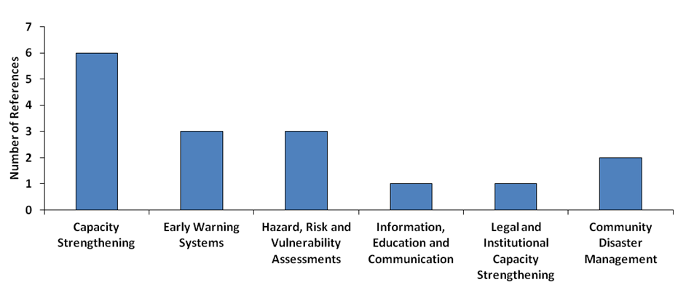
Figure 9. Key DRR Focus Areas for Saint Vincent and the Grenadines (Overall total of 16 references)
It was affirmed that the National Emergency Management Organization (NEMO) faced two major challenges with regards to capacity; human resources and financial resources. The challenges are being addressed but the process is usually too slow to be effective. Specifically, as outlined in the Saint Vincent and the Grenadines country profile, the growing number of volunteers for DRM does not possess vital technological skills. It was also noted that the majority of the agencies in a study (90%) had not designated disaster or emergency budgets while only 25% of agencies interviewed had formal business continuity plans. The country document highlights the fact that the greatest deficiency in capital for disaster risk is at the community level. As a result of these shortcomings, the document proposes structured and continuous training for community organizers and organizations as well as full incorporation of DRR into the education system.

The need for strengthening a NEMO communication system, as well as an island wide alert system through television, radio and SMS text messages, was emphasized in the Saint Vincent and Grenadines country document. It was also stated that a successful early warning system for hurricanes exists but there is a need for such a system for floods, as these events occur frequently without hurricanes.

Finally, it was noted that several local institutions indicated a need for strengthened capacities and resources to facilitate timely activation of the National Emergency Operation Centre (NEOC). Other concerns include the need for documentation of previous emergencies with lessons learnt to determine priorities for actions. Institutions are not familiar or comfortable with their roles in the NEOC and thus, the NEMO Secretariat has started addressing this through the development of the NEOC SOPs with CDEMA and a final draft has been presented.

In addition to the priorities found in the CD, the areas of awareness and CDM monitoring evaluation and reporting within the sectors were identified in the CWP. Drought mitigation measures are also required given the Saint Vincent and the Grenadines has been severely impacted in the last few years. Climate change adaptation in coastal communities is also a priority area for the country.

It was outlined in the Saint Vincent and Grenadines country report on DRR that Saint Vincent possesses recent hazard maps but the Grenadines does not. Also, though most areas prone to hazards are known by the Physical Planning Department, community hazard maps which delineate safe areas, hazard zones, shelters and escape routes do not exist. In addition to this there is a lack of a Saint Vincent and Grenadines community vulnerability tool. Other concerns highlighted under this area include the need to demarcate major floodplains using historical rainfall and quality and state of drain networks. As it relates to flood mapping, the linkages need to emphasised for physical planning and its roles in riverine communities and land use policy.

Suriname

National priorities were not available when finalizing the document.

Trinidad and Tobago
The DRR priorities are based on the draft CD and the results of the application of the Criteria tool. The following key priorities were indentified:
- Legal and institutional capacity strengthening
- Need for hazard, risk and vulnerability assessments
- Focus on drivers of risk
- Strengthen early warning systems

In terms of the legal and institutional capacity strengthening, reference has been made to the need for a comprehensive policy on disaster management and the development of a policy framework to guide national action on DRR and its related issues. Most plans and policies are at the draft stage. In addition, the legislation, particularly for building codes needs to be improved.
The needs related to hazard, risk and vulnerability assessments include the design and implementation of a hazard information system to track and monitor hazards across Trinidad and Tobago and to establish historical data for comprehensive disaster management. In particular, action plans need to be informed by multi-hazard studies that incorporate climate change. There is also a need for implementing early warning systems for hydro-meteorological incidents.

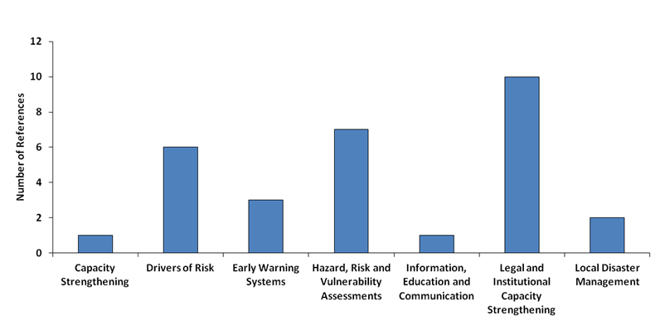
Figure 10. Key DRR Focus Areas for Trinidad and Tobago (Overall total of 30 references)
Drivers of risk have been linked to the socio-economic vulnerabilities that exist in Trinidad and Tobago and require urgent attention. The drivers of risk include economic vulnerability in the form of unemployment, threatened livelihoods and debt and social vulnerability in the form of lack of information or awareness of the hazards and belief systems. Other social vulnerabilities include:
- Family structure- Female headed households and households with a large number of dependencies are considered to be more vulnerable to the negative impacts of disasters.
- Illiteracy- Lack of education on the causes and mitigation measures that one can use to reduce the effects of flooding.
- Lack of personal safety- Some individuals have higher personal levels of acceptable risk and would therefore risk living in areas that are very prone to flooding.
- Special needs individuals such as the elderly and the mentally challenged would be more vulnerable to disasters.

National DRR Priorities Summary
The national priorities identified in the During the Caribbean DIPECHO Workshop 2014 countries presented their national DRR priorities, DRR achievements and challenges. A summary of the DRR priorities can be seen in the table 2. It needs to be noted that Cuba, Grenada and Saint Vincent and the Grenadines were not able to present their priorities during the workshop. For these countries the DRR priorities were taken from the previous section.

Table 2: National DRR priorities for 2015-2016
Country | Priorities
Barbados | - Fully functional Hazard Mitigation Council  - Mapping of floods and tsunami cartography to identify evacuation routes.  - Additional regulation to address gaps.  - Community emergency programme to be institutionalized
Cuba | - Reducing earthquake risk for the three south-eastern provinces  - Strengthen the hydro-meteorological EWS in the watershed of Zaza and Ciénaga de Zapata  - Prioritizing flood protection in the watershed of Zaza in Santi Spiritust (in the center of the island) with the involvement of the National Institut for Hydrological Resources (Instituto Nacional de Recursos Hidráulicos, INRH) and local governments  - Combining DRR and CCA measures towards flood protection and mitigation to in the Cienaga de Zapata watershed which is the largest wetland in the Caribbean.  - Strengthening of urban resilience.
Dominica | - CDM Legislation approved and implemented  - Robust Early Warning System EWS for multiple hazard risk to include seismic and Volcanic risk  - Increase public awareness and education related to DRM  - Enhance knowledge transfer and capacities nationally and locally  - Explore further the common alert protocol (CAP)
Dominican Republic | - Strengthen Local Capacities: Disaster Risk Reduction/Evaluation Plan  - Improve EWS alerts.  - Need for seismic and tsunami evaluations.  - Link to CCA.  - Baseline data development especially supporting the national information system.  - Integration of developed tools at local level.  - Information, Education and Communication.
Grenada | - Hazard Maps based on probabilistic criteria  - Enhancing the capacity of institutional response structures  - Budgetary allocation for resources for preparedness and emergency response  - Development of a legal and regulatory framework for DRM and Environmental Management  - Volunteer support coordination  - Development and maintenance of geo-referenced and territorially disaggregated records of frequent impacts of hazards related to seasonal events (droughts, floods or landslides)  - Implementation and development of studies and action plans on multi-hazard or trans-border hazard conditions, including extreme climate variability events such as the impacts of climate change  - Development of strategies for reducing vulnerabilities for the poor populations  - Improve access to the sectors of the population with limited access to essential services and reduce the vulnerability of essential services  - Development of a regulatory framework for DRM or for environmental management  - Implement planning processes or control over the implementation of the urban and rural land use planning regulations. Need physical control mechanisms for the occupation, use and transformation of urban landscape  - Development of formal coordination mechanisms by State agencies for Risk Management and Environmental Management
Guyana | - Revise National DRM Platform TOR.  - Reconstitute and strengthen the Civil Defence Commission. Capacity building in ITC.  - Strengthen sectoral capacities to incorporate DRM into planning, in the public and private sector.  - Standardized data management, and hazard, vulnerability and risk analysis and mapping with attention to exposure. Replicate for all sub-national regions.  - Expand hydro-meteorological monitoring network. Strengthen EWS, including floods, droughts and fires.  - Consider trans-boundary risks.  - Continue undertaking Public Education Campaigns on DRM.  - Replicate CBDRM initiatives. Support CCA&M initiatives at the local and community level.  - Mainstream gender and disability. Vulnerable groups.  - Access / implement risk transfer mechanisms.  - Operationalize Multi-Hazard Preparedness and Response Plan, and Land Use Plan.  - Strengthen regional (sub-national) Emergency Operations Centres and Volunteers Corps.  - Replicate shelters surveys at sub-national level. Upgrading of shelters.
Haiti | - Focus on urban risk, seismic and tsunami.  - Management of medical emergencies  - Need to strengthen capacity for training and drills.  - Review National DRR Plans.  - Improve Sectoral coordination.  - Involvement of private and public sector  - Increase simulation exercises (SIMEX). To have in-depth simulations.  - Integrate disaster risk reduction in the rehabilitation (mainstreaming DRR)  - Improve legislation for disaster risk management
Jamaica | - Enhance National Risk coordination system among partners for risk identification / mitigation.  - Improved EWS and ICT is a priority at national and community level.  - Multi-hazard evidence-based research to recraft priorities for DRR actions.  - Small scale infrastructure  - Local Disaster Management  - Gender / Youth / Special Population  - Baseline data development especially continuing existing community hazard profiling  - Hazard mapping analyses and assessments (multi-hazard approach)  - Strengthening institutional capacity for technical support
Saint Lucia | - Increase capacity for risk assessment.  - Geo-referenced data for risk mapping.  - Land use planning  - Improve capacity for DRR in local and national level.  - Multi-hazards policy and plans for decision making.  - Institutional strengthening
Saint Vincent and the Grenadines | - Capacity strengthening  - Improve early warning systems  - Need for hazard, risk and vulnerability assessments  - Focus on community disaster management  - Improve information, education and communication  - Legal and institutional capacity strengthening  - Need for drought mitigation measures  - Assessing the risk in schools and developing respective plans
Suriname | Not yet available.
Trinidad and Tobago | - Strengthen Knowledge Management Platform using integrated approach  - Encourage the BCM programme in the Private Sector for Small /Medium Enterprises  - Develop CDM Legislation to include IDRL  - Improving the Early Warning System to allow for an integrated approach (National Alert State Protocol and Public Alert / Population Alert System)  - Prioritise discussions with CDEMA regarding the shift of focus towards building resilience  - Continue the work with the Private Sector for more robust Public / Private Sector Partnership and participation  - Mainstreaming / Integrating DRR in all sectors

Regional DRR Priorities
The regional DRR focus areas were identified based on the categories that the majority of the countries highlighted at the national level. Based on this criterion, there were eight focus areas that can be considered as regional level attention. The eight focus areas are legal and institutional frameworks; information, education and communication; hazard, risk and vulnerability assessments; capacity strengthening; early warning systems; local disaster management; drivers of risk; and baseline data development (Figure 11).

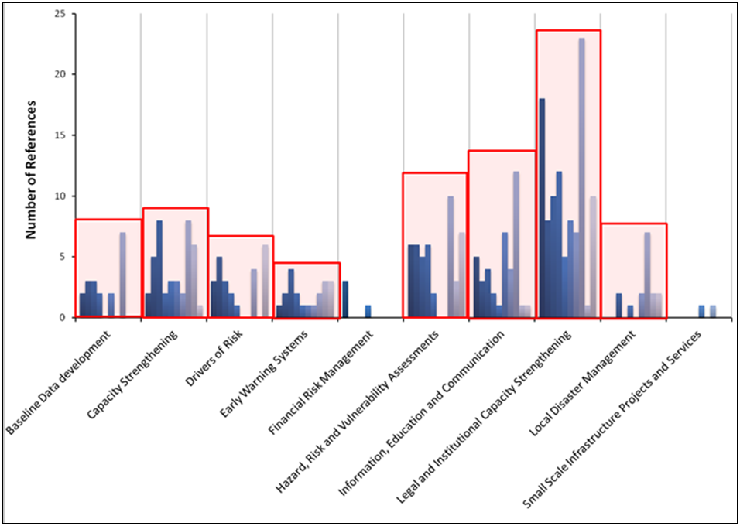
Figure 11. Regional DRR Focus Areas Based on Priorities Identified at the National Level

Based on the national priorities presented during the Caribbean DIPECHO workshop the following regional priorities have been identified:

- Early Warning System is a priority at national and community level.
- Seismic risk with special focus on urban settlements (urban risk).
- National risk coordination system among partners for risk identification / mitigation.
- Joint DRR programs with private sector participation.
- Develop laws and policies linking up to regional and international framework.

The regional priorities identified by countries in the DIPECHO workshop are consistent with the analysis of the CDs, Criteria results and CWPs. Countries were able to identify more specific DRR national priorities from the broad focus areas identified in the analysis. The legal and institutional framework that is well anchored in the regional and international DRR framework and well integrated into the sectors and non-public partners at all levels are two key elements reflected in both the workshop and the analysis. Seismic urban risk is however a narrower scope of the results of the analysis that identifies hazard, risk and vulnerability assessments at the local to national levels.

Conclusion

The preparation of country documents including the application of the Criteria aims to provide a holistic picture of DRR at the national level. This process has allowed countries to determine their progress in reducing risks and in identifying critical next steps.

The legal and institutional framework for DRR encourages the true application of the CDM strategy and framework for the region in that it focuses the attention of the national partners on prevention, mitigation and preparedness for all hazards. The legal and institutional framework requires commitment from the national level to appropriate the necessary technical and financial resources as an investment in DRR and sustainable development. Both the institutional and capacity strengthening are therefore required if DRR is to become institutionalised at the national to local levels.

Capacity strengthening involves both the expansion and enhancement of capabilities for DRR across all levels and sectors of society. Countries have recognised the need for hazard, risk and vulnerability assessments that can support development planning. Multi-hazard assessments and assessments that incorporate climate change are recognised as key needs within the countries. While vulnerability assessments are being undertaken in communities across the region under the Red Cross for example, there is a need to broaden the application. Training and education at both the community and national levels are important vehicles for accomplishing this task.

Public awareness and education has been identified by every country for attention. Any intervention at the local, national or regional level should involve an element of information, education and communication, noting that the lack of information contributes to risk exposure and vulnerability.

Risk governance is an area that has not been mentioned much in the documentation. It is however an area that should be reflected in the discussion on DRR particularly because there are many actors representing many sectors that are impacted by and contribute to hazard impacts. Governance is overarching and focuses on processes and mechanisms. Risk governance captures information on the normative environment for DRR, comparing this with what actually happens. Risk governance requires attention if gains are to be made in DRR at the appropriate geographical scales.

Annex 1. Match against the priorities of the 2013-2014 DIPECHO Action Plan per hazard and international agendas

The focus areas for each country were also matched against the priorities of the 2013-2014 DIPECHO Action Plan per hazard and international agendas. The results are shown in Figure 12. The DRR priorities identified within this report are further detailed for each 2013-2014 DIPECHO Action Plan priority per hazard (Table ) and the thematic areas that are related to the international agendas (Table ). Based on the information available from the CDs and the results of the Criteria, countries will need to define priority actions.

Based on Table and the number of countries associated with the priority per hazard, it is recognised that the areas of floods and hurricanes and climate change strategies may be of greatest concern for the countries. The Eastern Caribbean has been severely impacted by flood and hurricane events in the recent past and hurricanes remain a constant threat. Flooding has been associated with both the hurricane events, other intense rainfall events and as a result of riverine flooding. Flood and hurricane events are therefore a very important area for DRR action in most of the countries and actions should be developed around this theme across the region.

In terms of the climate change strategies, six countries have indicated a need to address this thematic area. This is an area of concern for all SIDS however as the impacts of climate change are believed to disproportionately negatively impact both their hydro-meteorological systems as well as undermine investment in coastal infrastructure and tourism.

Actions related to earthquakes and tsunamis were dominated by the Dominican Republic and Haiti and also Jamaica as the key geographical locations under the 2013-2014 DIPECHO Action Plan priorities. There is however the threat of earthquakes and tsunamis throughout the rest of the Eastern Caribbean with the tsunami threat being one that the public is least sensitised on.

Targeted countries also identified priorities for DRR intervention for drought and exposure of densely populated areas with vulnerable communities. With the Caribbean Institute for Meteorology and Hydrology poised to become a regional centre for drought monitoring along with other partners, the implementation of programmes and projects at the regional, national and local levels can benefit from ECHO support. As it relates to densely populated areas, interventions are being sought in five countries. In general, the interventions are for the creation of the mechanisms to reduce urban risks.

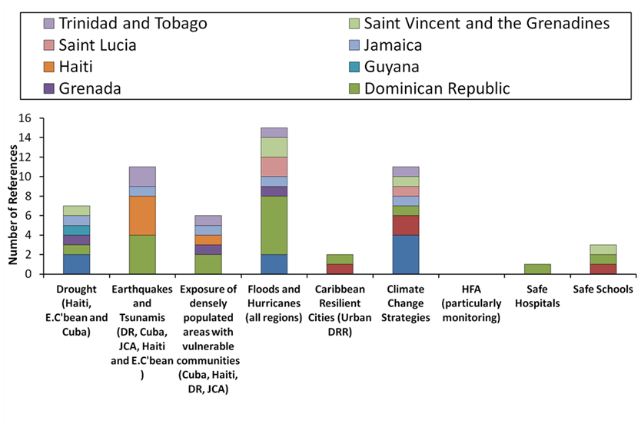
Figure 12. Countries with DRR priorities corresponding to the focus areas of 2013-2014 DIPECHO Action Plan

Table 3. 2013-2014 DIPECHO Action Plan hazard focus by Country
Drought (Haiti, EasternCaribbean and Cuba)
Barbados | National Drought Management Committee should be established
Dominican Republic | Drought research studies with a focus on agriculture
Grenada | Development and maintenance of Geo-referenced and territorially disaggregated records of frequent impacts of hazards related to seasonal events (droughts, floods or landslides) -There are zones without records of recurring impacts from seasonal phenomena. Recurring impacts are considered critical and high priority, although still without detailed studies
Guyana | Limited capacities for Early Warning. Strong progress in floods, but other hazards need to be considered, namely droughts and fires.
Jamaica | Early Warning Systems (EWS) for disaster risk reduction enhanced at the national, parish and community levels for all hazards
Saint Lucia | Hazard/risk maps for drought; vulnerability maps for drought (precipitation change) developed under Second National Communication on Climate Change - illustrate potentially vulnerable zones/areas
Saint Vincent and the Grenadines | Drought monitoring and development of Water Safety Plan
Earthquakes and Tsunamis (DR, Cuba, JCA, Haiti and E.C'bean )
Dominican Republic | Enact municipal regulations for land use and building codes to adopt earthquake resistant standards.  Identify suitable locations for shelter camps in case of an earthquake. Provide equipment and training.  Conduct hazard studies for tsunamis and shoreline dynamics (sea level rise and loss of coastal area due to Climate Change).  Tsunamis research studies in Patos and Paraíso.
Haiti | Promote the exchange of information (disseminate lessons learned post-earthquake) Regular coordination SNGRD (CNGRD, SPGRD, GACI, Societe Civile AGERCA and Club des amis d’AGERCA) Coordination and regular functioning of the thematic committees and the Committee on Seismic Risk and Tsunami: To support and develop thematic. The achievements of the UNESCO / Tsunami project in Grand Nord are replicated in the Grand Sud.  Support efforts to reduce urban risk - urban risk and tsunami risk projects
Jamaica | Early Warning Systems (EWS) for disaster risk reduction enhanced at the national, parish and community levels for all hazards
Trinidad and Tobago | Lack of Information and beliefs. Citizens are unaware that there are six (6) seismogenic zones in Trinidad and Tobago; according to the University of the West Indies Seismic Research Centre. Some people still believe that Trinidad and Tobago would not be affected by a major earthquake.
Exposure of densely populated areas with vulnerable communities (Cuba, Haiti, DR, JCA)
Dominican Republic | Promote urban planning, relocation of houses and reduction of squatting in risk areas (natural phenomena, pollution sources and anthropogenic risks)  Elaborate municipal land use plans, considering uses such as hotels and urban areas of high exposure.
Grenada | Development and implementation of mechanisms to limit squatting in hazard prone urban and suburban areas.
Haiti | Support efforts to reduce urban risk - urban risk and tsunami risk projects.
Saint Lucia | Rapid urbanisation of former rural areas of the island have led to denser populations living in unplanned or informal settlements increase risk with regard to natural and human induced disasters
Trinidad and Tobago | There is a high and increasing occupation of urban areas at risk (over 30% of the population of the analysis area) without planning processes or control over the implementation of the urban and rural land use planning regulations. Lack of physical control mechanisms for the occupation, use and transformation of urban landscape.
Floods and Hurricanes (all regions)
Barbados | An inventory of vulnerable housing infrastructure must be conducted, so that impact zones may be delineated for wind and flash flood hazard assessments
Dominica Republic | Promote environmental educational campaigns and involvement of the population living in the Ozama and Haina river banks in environmental protection and sustainable use of natural resources.  Promote the implementation of an Early Warning System (EWS) for flood in the main rivers and tributaries in Ozama and Haina river basins, ensuring sustainability and ownership.  Train and support farmers with a backup system, to enhance response capacities and resilience to floods.  Strengthen EWS for the entire hydrologic system.  Implementation and strengthen of flood EWS.  Implementation and strengthen of flood EWS in the following provinces:  - María Trinidad Sánchez: Río Boba, population of Las Gordas district.  - Espaillat: Río Moca, Yásica and Joba; population of the city centre of Moca.  - Hermanas Mirabal: Río Jayabo, population of Villatapia municipality.  - Puerto Plata: Río San Marcos; cañada Villa Progreso, Loma Isabel Torres and Aguas Negras. Río Camú, in Montellano. Río Bajabonico, in the western municipalities.
Grenada | Development and maintenance of Geo-referenced and territorially disaggregated records of frequent impacts of hazards related to seasonal events (droughts, floods or landslides) -There are zones without records of recurring impacts from seasonal phenomena. Recurring impacts are considered critical and high priority, although still without detailed studies
Jamaica | Early Warning Systems (EWS) for disaster risk reduction enhanced at the national, parish and community levels for all hazards
Saint Lucia | Need for flood management; The island-wide flood hazard maps identify likely regions to be flooded for extreme rainfall and give a mean depth of flood waters within regions. They do not provide detailed information of flood water levels, velocities or locations of specific hazardous places. Further, they cannot incorporate detailed hydraulic properties of drainage facilities in the region. Notwithstanding these limitations, these maps can still be quite useful
St. Vincent and the Grenadines | The need to demarcate major floodplains using historical rainfall and quality and state of drain networks.  There is a need for early warning systems for floods, as these events occur frequently without hurricanes.
Trinidad and Tobago | Lack of education on the causes and mitigation measures that one can use to reduce the effects of flooding.

Table 4. 2013-2014 DIPECHO Action Plan Focus Areas Related to the International Agendas by Country
Caribbean Resilient Cities (Urban DRR)
Dominica | Development and testing of Disaster Management Plans for schools and other critical infrastructure in populous communities
Dominican Republic | Elaborate municipal land use plans, considering uses such as hotels and urban areas of high exposure.
Climate Change Strategies
Barbados | At the sectoral levels, key sectors such as agriculture and fisheries remain weak in terms of understanding the effects of climate change on the sector and pre-planning to ensure food security and employment nationally.  Prioritisation of investments in climate change adaptation measures which will also serve to secure investments in economic sectors through reduction of disaster risk e.g. ecosystem conservation.  Historical information and hazard studies show the existence of multi-hazard zones or areas, but integrated scenarios and studies are not conducted for multi-hazard, trans-border hazards and/or impacts of climate change. There are no action plans.
Dominica | Integrating climate change and forecasting into DRR strategies  The absence of climate change impacts in risk management strategies. It was specifically noted that very few records on risk scenarios and impacts of climate change exist.
Dominican Republic | Conduct hazard studies for tsunamis and shoreline dynamics (sea level rise and loss of coastal area due to Climate Change).
Jamaica | Enhanced community capacity to cope with the adverse effects of climate change and disasters (Outcome 1 of Logical Model and PMF)
Saint Lucia | Need for climate change adaptation
Saint Vincent and the Grenadines | Need for climate change adaptation in coastal communities
Trinidad and Tobago | There are scenarios about the impacts of climate change, but they are not coordinated or integrated into the risk management strategies.
HFA (Particularly Monitoring) | While not specified within the Country Documents, all countries highlighted the need for support undertaking the sensitisation of national stakeholders to the HFA and support for monitoring and reporting on progress given limited human and financial resources.
Safe Hospitals
Dominica | Development and testing of Disaster Management Plans for schools and other critical infrastructure in populous communities.
Dominican Republic | Promote safety assessments in public and private hospitals.
Safe Schools
Dominica | Development and testing of Disaster Management Plans for schools and other critical infrastructure in populous communities.
Dominican Republic | Promote safety assessments in schools.
Saint Vincent and the Grenadines | NEMO and the Ministry of Education has commenced the development of the Safe Schools Policy and it is a priority area for DRR in assessing the risk in schools and developing respective plans

ec.europa.eu/echo/files/funding/decisions/2013/HIPs/DIPECHO_caribbean_op.pdf
An operational National Multi-Hazard Disaster Management Plan
Enhanced disaster awareness among the public
National agencies (Ministries of Health, Agriculture, Transport and Works and the Barbados Light and Power) able to manage localised or national emergencies/disasters through the coordination of the National Emergency Operation Centre (NEOC)
Increased capacity of National departments and agencies to effectively prepare for and respond to emergency and disaster incidents
Output 2.2 - Robust Evacuation Systems for priority hazards established and reviewed; 3(a) Training of stakeholders in standardized hazard mapping techniques & analysis; 3(c) Training of stakeholders in conducting standardized vulnerability assessments for the community level
Output 2.3 - National Emergency ICT /Communications System upgraded - For Dominica the use of ICTs in disaster management, outside of radio communications, is an area with space for improvement. The thrust for this five-year period therefore is an improved and well maintained redundant national emergency communications system and the introduction of new technologies for monitoring the on-set of the priority hazards and for supporting early warning systems. The hazards of focus are riverine floods, volcanoes and earthquakes; 2. EWS for priority hazards developed and exercised; (There is need for improvements in the system for securing and maintaining seismic and tsunami monitoring equipment)
Output 4.2 - Education Awareness Programmes are designed for key target groups- media, schools, homeowners and the construction industry
Outcome 1.1 CDM model legislation and policy reviewed, enacted and adopted respectively; 1.9.1. Develop and enforce the national land use policy; 1.9.2. Enact revised planning bill to support the existing planning regulations; 1.9.3. Sensitize and enforce revised Building Codes, inclusive of the fire code; 1.9.4. Enforce laws against the practice of bush burning during dry season; 1.9.5. ICZM Policy finalized (GIZ Project); 1.9.6. Ratify the International Maritime Convention for the Prevention of Pollution from Ships (MARPOL); 2.8.1. Enforce international regulations regarding port facilities e.g. International Ship and Port Facility Security (ISPS) Code. Maritime Search and Rescue: 3.4.1. Sign the regional Maritime SAR agreement; 3.4.2. Ratify the International Search and Rescue Convention (SAR Convention); 3.4.3. Strengthen existing Search and Rescue cooperation within the region through the signing of MoU with key partners; Output 4.3: Multi-hazard National Recovery Policy and Plan Developed.
Outcome 1.3 Technical staff at NaDMA (Secretariat) adequately trained.
1.7.1. Mapping of hotspot areas of bush fire susceptibility, oil spill; 1.7.2. Conduct analysis and mapping of tsunami, storm surge hazards via bathymetric studies and inundation mapping; 2.6.1. Develop evacuation plans for hazards, namely volcano, hurricane, storm surge, tsunami, landslide, flooding, earthquake, drought.
3.5.1. Conduct Training for DMCs in Disaster Risk Management; 2.5.1. Develop a CDM training programme for Media Personnel; 2.5.2. Deliver and evaluate training programme for Media Personnel 2.5.3. Utilized trained media personnel in PEA programmes
1.4.1. Adopt model approach to developing and implementing a comprehensive programme of safety and risk-reduction in schools, via the CDEMA School Safety Programme; 1.6.1. Public education and awareness programmes on ecosystem friendly agricultural practices to build resilience. Eg. Promote the practice of terracing throughout the farming community to reduce the likelihood of landslide; 1.6.2. Public education and awareness programmes on disease outbreaks, heat stress conditions and fire-prevention; 1.6.3. Implementation of NaDMA tsunami smart sensitization programmes.
1.5 Capital projects for risk mitigation implemented; 1.5.1. Design and implement sea defence mechanisms; 1.5.2. Construct artificial reefs, and moorings that meet standards in targeted areas; 1.5.3. Develop mechanisms for the management of bush overgrowth in the bush-fire-prone areas 1.5.4. Implement, monitor and maintain flood mitigation programme in communities prone to flooding, e.g. St. Mark's Project (Flood Mitigation Project); 1.5.5. Using the landside hazard maps developed for Grenada, promote the construction and/or maintenance of proper drainage systems in order to reduce likelihood of landslide occurrence, and reduce impact of flood events; 1.5.6. Identify and source funding to implement the risk mitigation projects.
Outcome 2: Disaster Risk Management mainstreamed at national and parish levels and incorporated into key sectors; Outcome 4 Preparedness, Mitigation, Response and Recovery Systems Strengthened; Output 2.1 Enhanced institutional capacity of key agencies, sectors and local authorities to manage disasters; Output 2.2 Prevention, mitigation, preparedness , response and recovery procedures developed for key sectors; Output 4.2: Emergency Communication Systems in place and functioning; Output 4.3: Emergency response and early recovery capabilities strengthened; Output 4.4: Improved coordination between agencies for disaster management
Outcome 1 Enhanced community capacity to cope with the adverse effects of climate change and disasters; Output 1.2: Enhanced community capacity in disaster preparedness and mitigation
Outcome 2: Strengthened leadership capacity for effective governance in CDM programme implementation; Outcome 4: Hazard resilient and prepared communities that incorporate all-sector engagement.
Integrated national early warning system protocols for effective hazard monitoring.
Outcome 1: Improved hazard identification and vulnerability reduction techniques that support policy development and decision making for sustainable development.

